Realistic Car Controller V3.4 by

BoneCracker Games
First of all, thank you for purchasing and using Realistic Car Controller! This documentation will guide you to;
Contents
First to Do! 3
Script Execution Order 4
Overview 4
RCC_CarControllerV3.cs 5
RCC Settings 7
Configurable Ground Materials 8
RCC Scene Manager 9
Controller Types 10
Mobile Controller 10
About Mobile Usement On City Scene 11
Xbox Controller 11
Creating New Vehicles 13
Warning 13
Important 13
Spawning New Vehicles With Code 16
Spawning New Vehicles With Given Position, Rotation, Sets It’s Controllable, And Engine State 16
Registering Vehicle As Player Vehicle 16
De-Registering Player Vehicle 16
Setting Controllable State Of The Player Vehicle 16
Collider Shapes Of The Vehicle 17
Driving Assistances 18
Dashboard Configuration 19
Damage 19
Creating Lights, Sounds, Skidmarks, Smoke Effects, And Other Features 20
Ground Materials 20
Adjusting Ground Particles, Wheel Sounds, Damp, Forward and Sideway Stiffness, Slip On Different Grounds 21
Terrain Ground Materials 22
RCC Camera System 23
Record / Replay 23
Customization 25
How The Customization Panel Works 25
AI Configuration 26
Creating NavMesh For Scene 26
Adding AI Controller To Vehicle 28
Adding Waypoints Container To Scene 29
Adding BrakeZones Container To Scene 30
Enter-Exit System 30
Multiplayer with Photon2 31
F.A.Q. 33
Credits 34
Sofie With Animations by 3DMaesen 34
Sound Effects 34
License 34
You can find more updated details on

http://www.bonecrackergames.com/realistic-car-controller
https://www.youtube.com/playlist?list=PLRXTqAVrLDpoW58lKf8XA1AWD6kDkoKb1
(You can zoom in with CTRL + ScrollUp for enlarge PDF pages)

First to Do!
Always backup your project before updating any asset or Unity Editor. Keep your own assets outside from RealisticCarControllerV3 folder. Delete the entire folder, and import updated version.
This version of the RCC is using LayerMask for avoid unwanted raycast hits and ignore unnecessary projector layers. Just create one layer for vehicles, and make sure it’s selected in RCC Settings. Also you can import it from Welcome Screen, but it will overwrite your Tags & Layers.
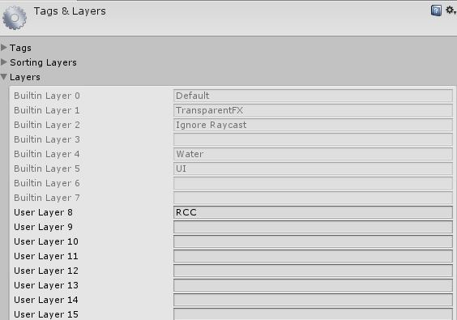

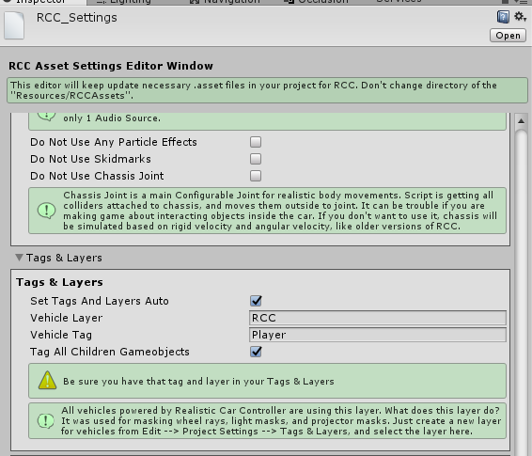
(Tools BoneCracker Games Realistic Car Controller RCC Settings)

Script Execution Order
This version of the RCC is using Script Execution Order for avoid unexpected event conflicts. This should be imported successfully when RCC installed, and doesn’t require any action. Just make sure you have this order. You can check it in Edit Project Settings Script Execution Order.
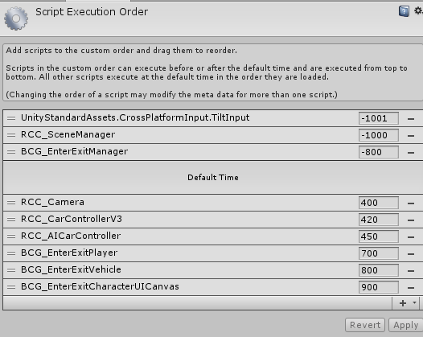

Overview
Each vehicle has it’s own RCC_CarControllerV3.cs script. Each vehicle is responsible for own RCC_CarControllerV3.cs. All global shared settings are located in RCC Settings (Tools BCG RCC Edit Settings). Lights, cameras, exhausts are addons and not required as an essential. Inputs are processed by InputManager.cs script. It will receive corresponding inputs from selected device. All other main topics can be found below.

RCC_CarControllerV3.cs

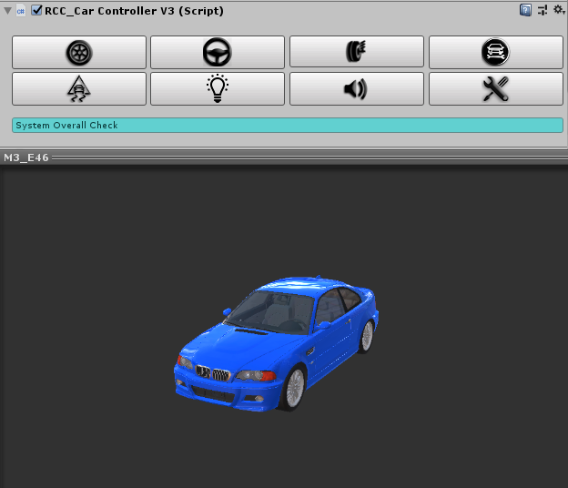

8 Main Categories for easily and understandable creating/configurating vehicles.
Wheels, Steering, Suspensions, Mechanic Configuration, Stability, Lights, Sounds, and Damage.

All vehicles are sharing global settings, sounds, configurations via RCC Settings.
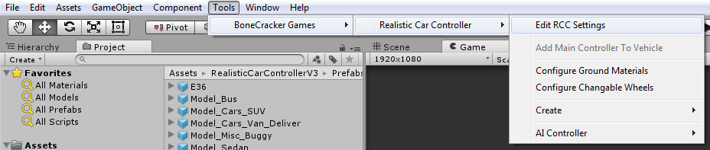

Changing ground materials physics, particles, damps, sounds, etc in Tools BoneCracker Games Realistic Car Controller Configure Ground Materials.
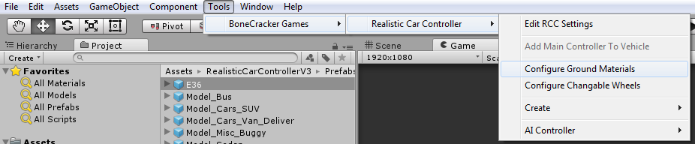

You may want to enable In-Scene buttons to create addons fastest way. Tools BoneCracker Games Realistic Car Controller Enable In-Scene Buttons.
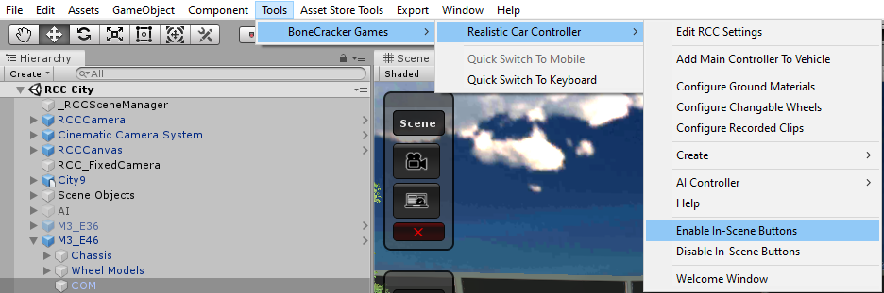

Creating lights, exhausts, mirrors, cameras, etc in Tools BoneCracker Games Realistic Car Controller Create.
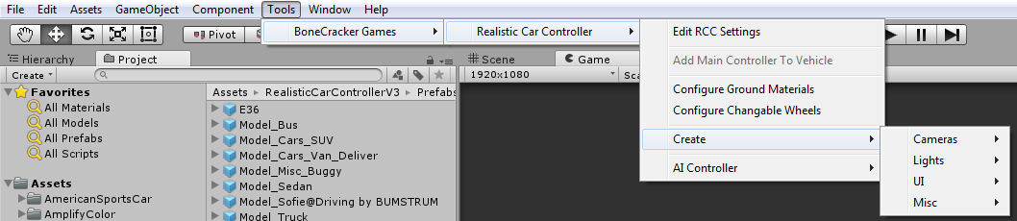
Making vehicles controlled by AI in Tools BoneCracker Games Realistic Car Controller AI Controller.
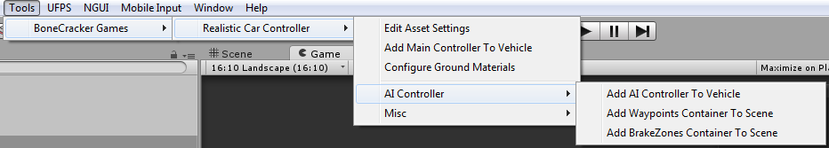

RCC Settings
Main RCC Settings. It’s shared by all vehicles powered by RCC. Tools BoneCracker Games Realistic Car Controller RCC Settings.
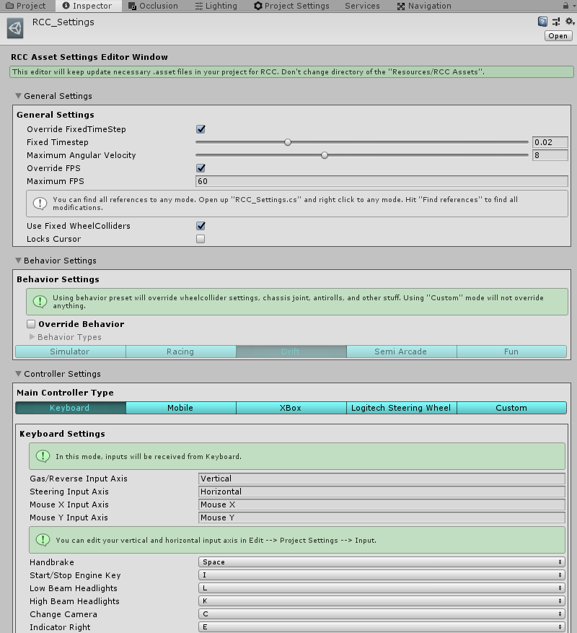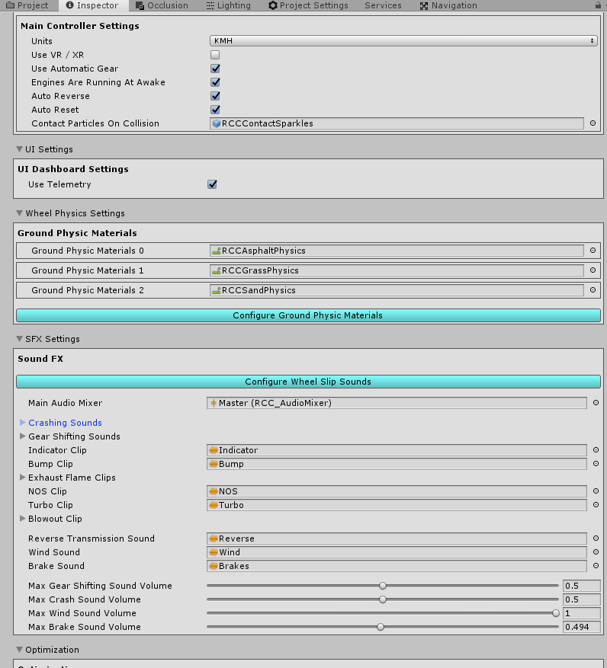
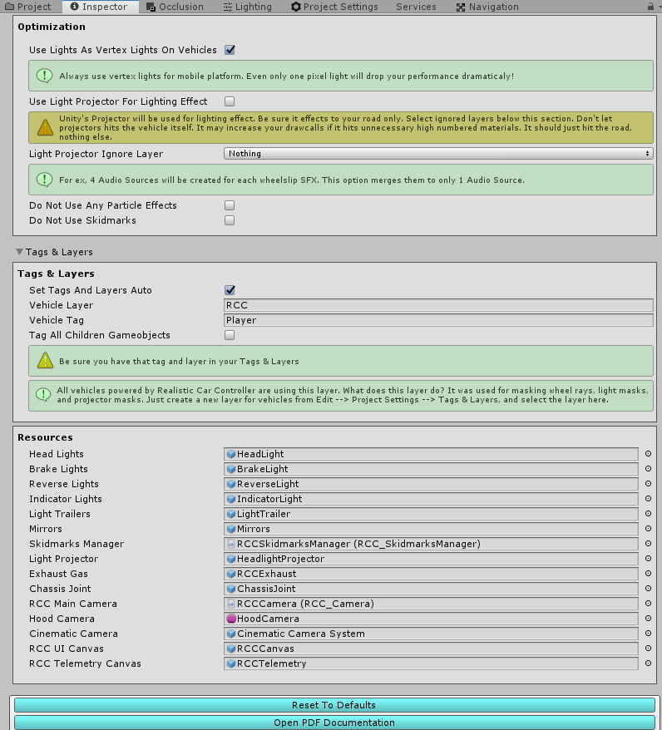

Configurable Ground Materials
Changing or adding new ground materials physics, particles, damps, sounds, etc in Tools BoneCracker Games Realistic Car Controller Configure Ground Materials.
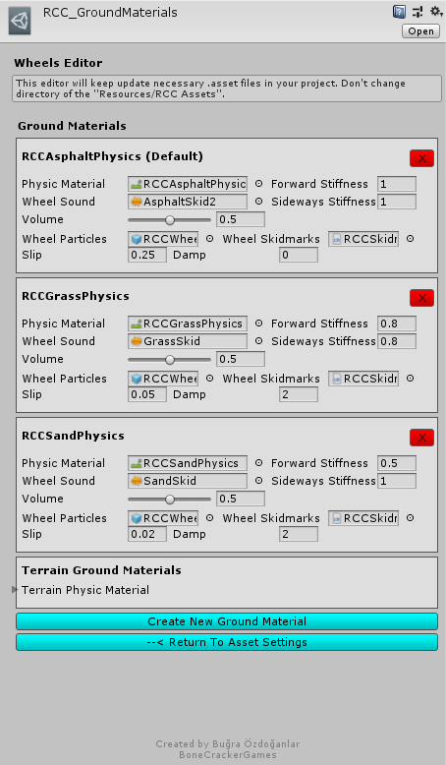
If WheelCollider hits a collider with one of the physic material in list, changes will be applied to WheelCollider. You can check out demo scenes.

RCC Scene Manager
Every scene will have this manager automatically. RCC Scene Manager contains current player vehicle, current player camera, current player UI, current player character, recording / replay mechanim, and other vehicles as well. Instead of finding current car controller, or camera on scene, RCC Scene Manager will find it and manage it only. All other scripts depending on player vehicle will take reference of the RCC Scene Manager. For ex, finding player vehicle on scene is RCC_SceneManager.Instance.activePlayerVehicle.

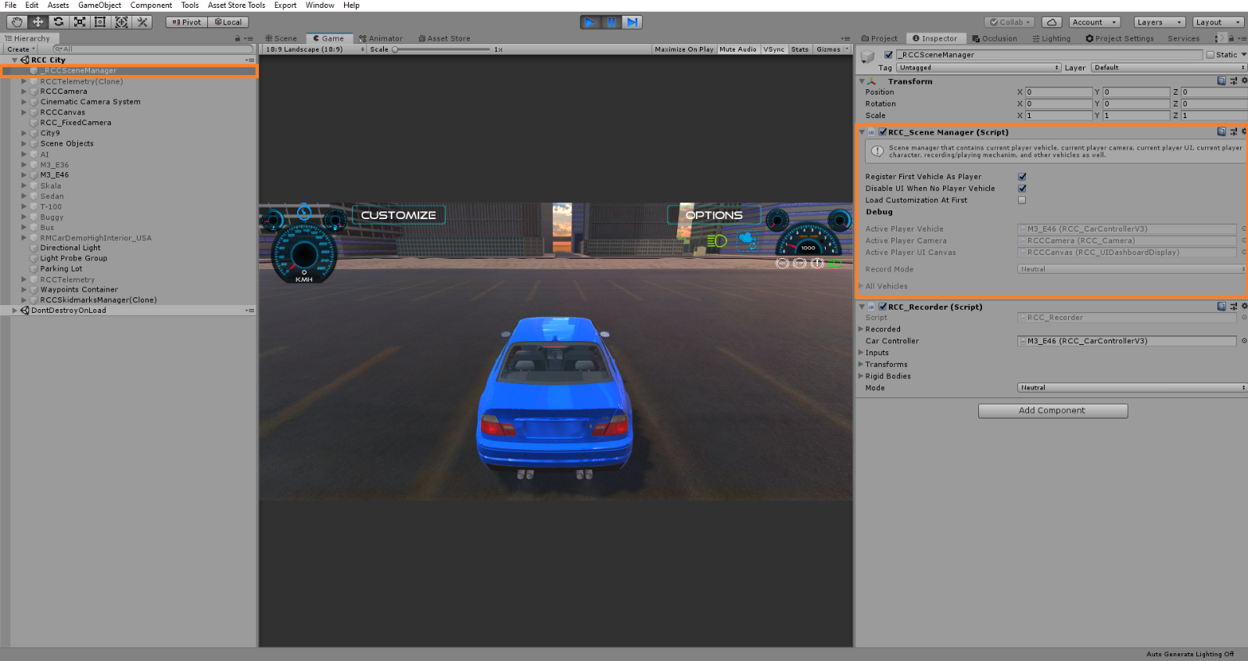

Controller Types
RCC supports 5 controller types ready to use. Keyboard, Mobile, Xbox, PS4, Logitech Steering, and Custom. Each controller has unique settings in RCC Settings. Also you can use your own inputs with Custom mode. Logitech Steering requires Logitech Gaming SDK installed in your project.

Mobile Controller
Package contains Mobile Controller ready to use with UI. Now let’s make our vehicles can be controller by Mobile Controller. Just open up RCC Settings from Tools BoneCracker Games Realistic Car Controller RCC Settings. You can change your inputs for Keyboard, Mobile Controllers, Xbox, Logitech Steering, and Custom Controllers here. Simply switch your controller type to Mobile. Mobile controller buttons will be activated in play mode.

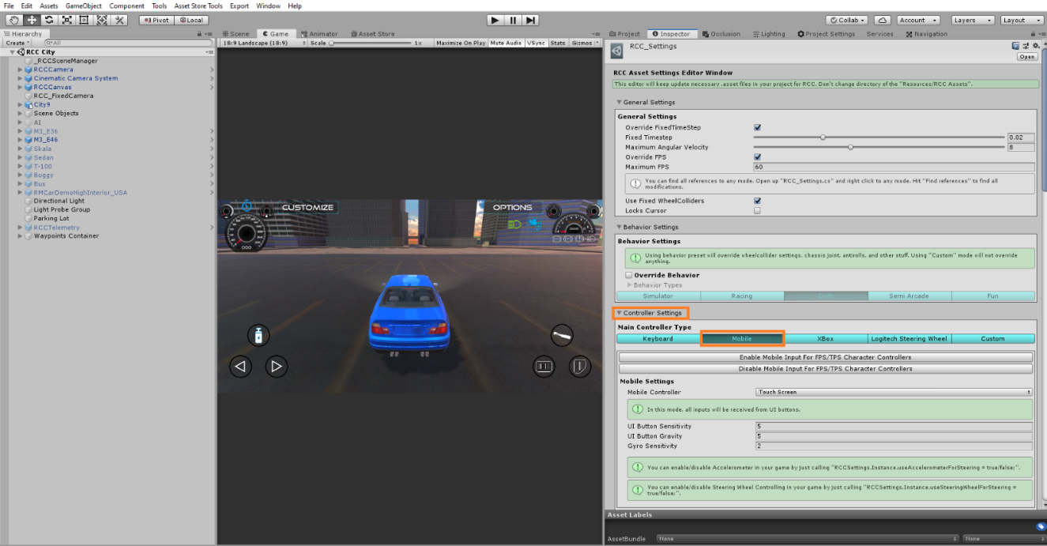

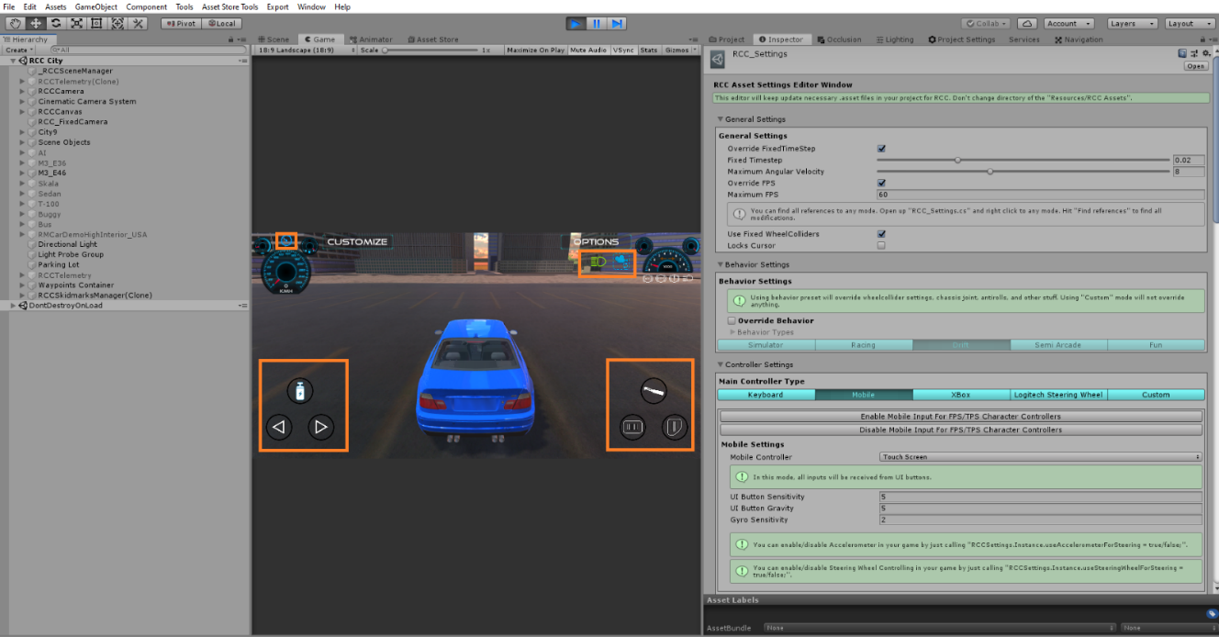
Each UI controller gameobject has “RCC_UIController.cs” script for inputs. These buttons feeds InputManager with normalized float values. You can adjust UI buttons sensitivity and gravity from RCC Settings.

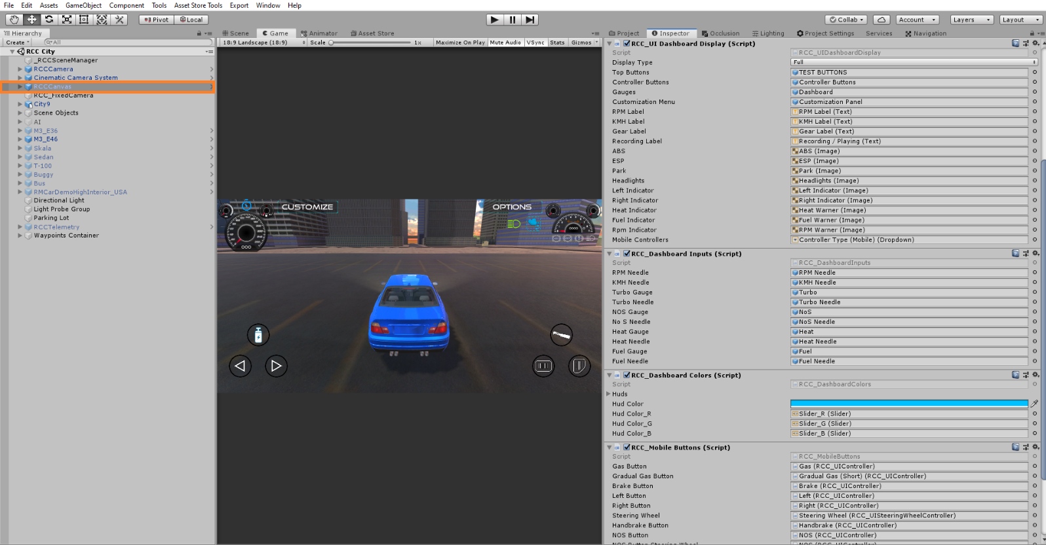

About Mobile Usement On City Scene
City scene has lot of specular maps with alpha channels. Textures with alpha channels are heavy for mobile devices. In Demo APK from my website is not using any texture with alpha channels. Also all standard shaders are replaced with mobile shaders in RCC City Mobile scene. If you build an APK without editing materials, you will get performance loss.

Xbox & PS4 Controller
This version comes up with Xbox and PS4 controller support. You can configure and remap inputs from Tools BCG RCC Edit Settings. Select “Xbox / PS4” controller, you will be able to edit them.
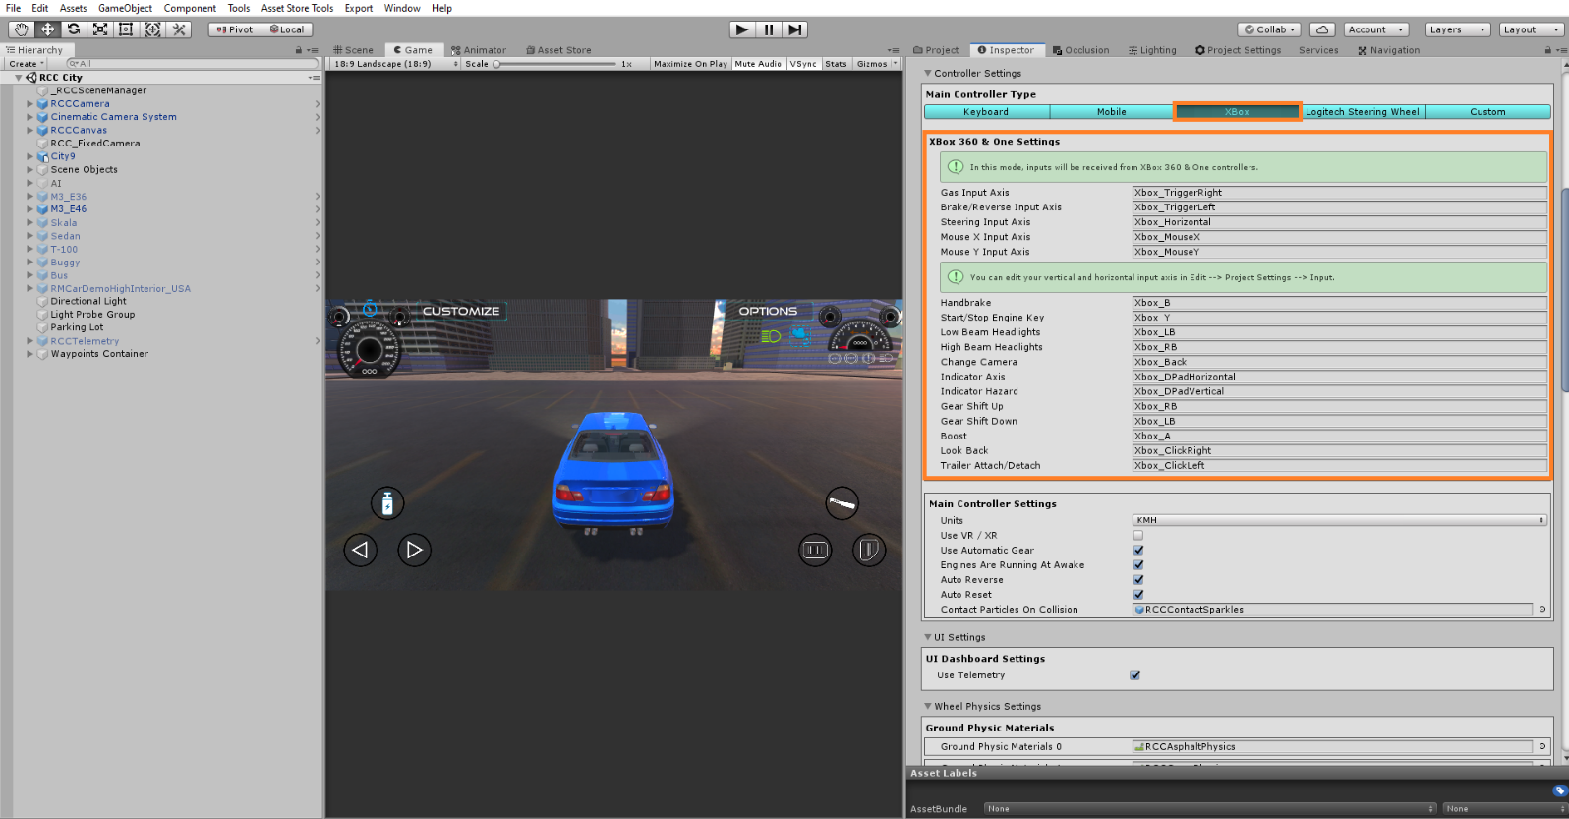

Xbox inputs are using Unity’s Input Manager class. Therefore, all proper Xbox controller inputs must be typed in correctly. You have to do it one by one in Input Manager. But RCC comes with InputManager.asset file ready to use it. You can import InputManager.asset from Tools BCG RCC Welcome Window. Be aware that if you import InputManager.asset to your project, current settings will be overwritten.

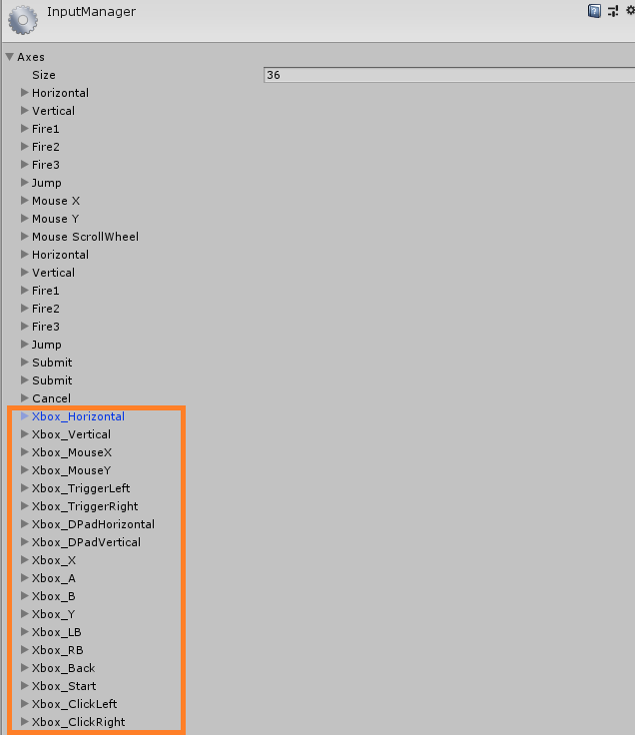
You will get this preset when you have imported it.

Creating New Vehicles
Some developers struggling with creating new vehicles. So, i have improved some editor scripts for simplify creating new vehicles.

Warning
Script and behavior depends on vehicle X, Y, Z directions and pivots. So, your vehicle model and wheel models transform directions should MUST be correct. Unity has updated EULA about it at 2018, and any models with inproper axes and directions will be rejected from Asset Store.

Important
Be sure you are in PIVOT and LOCAL mode while checking axes of your model.

X should be Right,
Y should be Up,
Z should be Forward.
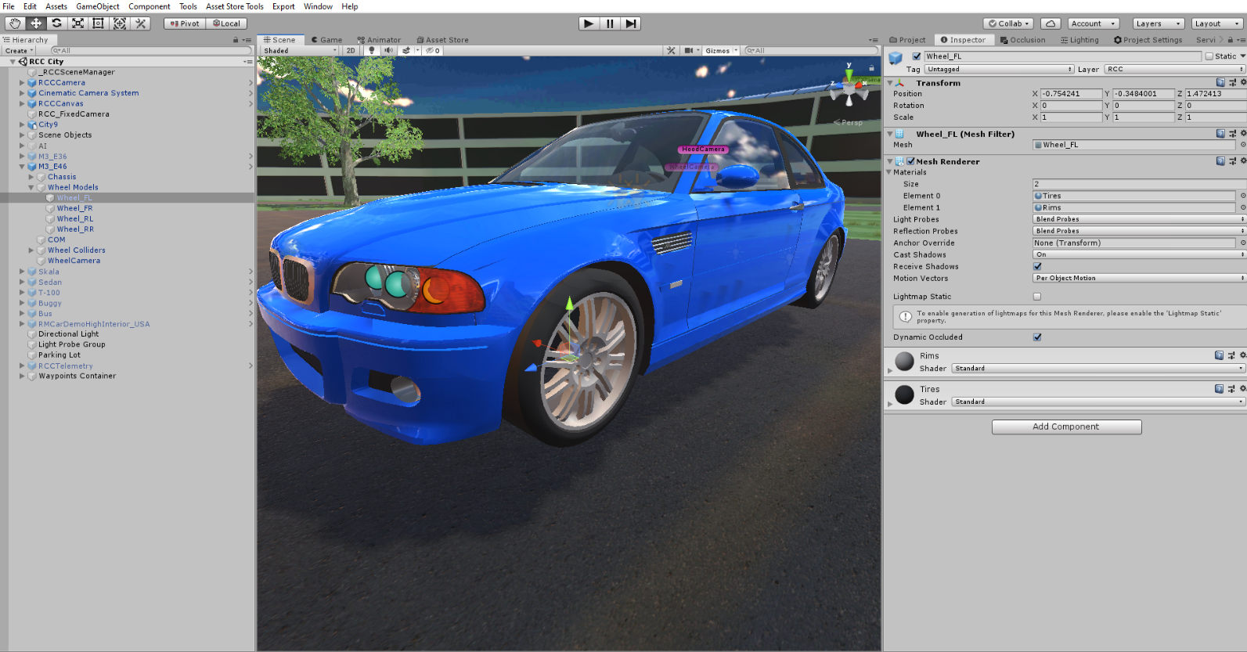

Many designers are making models with wrong directions or wrong pivot positions or both of them. This is really painful if you don’t know how to fix models directions. But I’ll explain it with two easy ways to fix this;
1 – Create a empty Gameobject at the center of the model, and rotate the new Gameobject to correct directions. Then parent your model in to this new Gameobject. It’s simple.

2 – Fix model’s directions and pivot positions inside your designing software. You can check videos on Youtube for how to do this in 3ds Max.
3 – There are many free assets in Asset Store to fix pivot positions in a second. You can check them too.

Also scale of your vehicle must be not oversized or miniature. Even if you want to make a toy car game, car size should be nearly same with demo vehicles. PhysX is calculating shape and size of the collider too. So, you have checked inputs, your vehicle and wheel models pivot positions, and their X, Y, Z directions. Everything is OK right? Then...

Drag and drop your vehicle model to your current scene and let’s get started;

You have to add Main Controller to root of the vehicle. Just select your vehicle model on your scene, and click Tools BoneCracker Games Realistic Car Controller Add Main Controller To Vehicle.

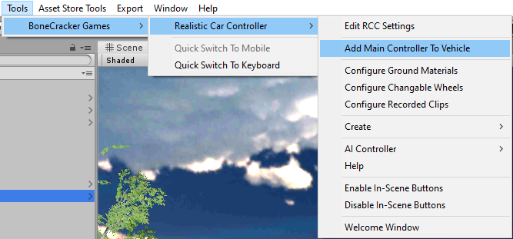

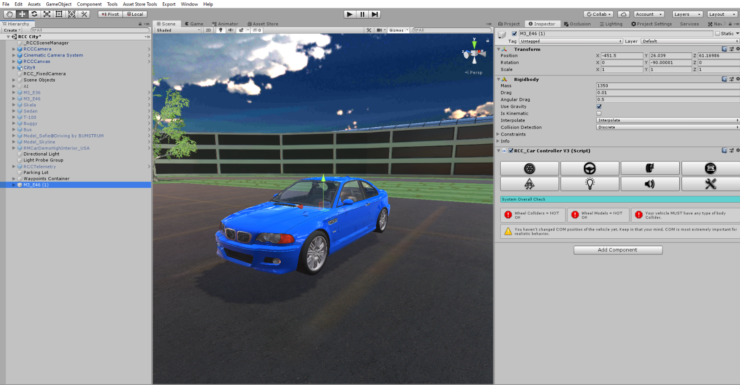
As soon as when you added RCC_CarControllerV3.cs script to your car, Rigidbody component will be added automatically. Set your mass to around 1250-1500 for this type of the vehicles. Interpolate Mode = Interpolate, Angular drag is around 0.25 – 0.50 for medium angular velocity. These rigidbody settings are applied when you create your vehicle automatically.

Click “Wheel” tab in the editor script. Select all of your wheels. After selecting your wheel models, click the “Create Wheel Colliders” for creating Wheel Colliders with proper radius, suspension, damper, and friction curves automatically.

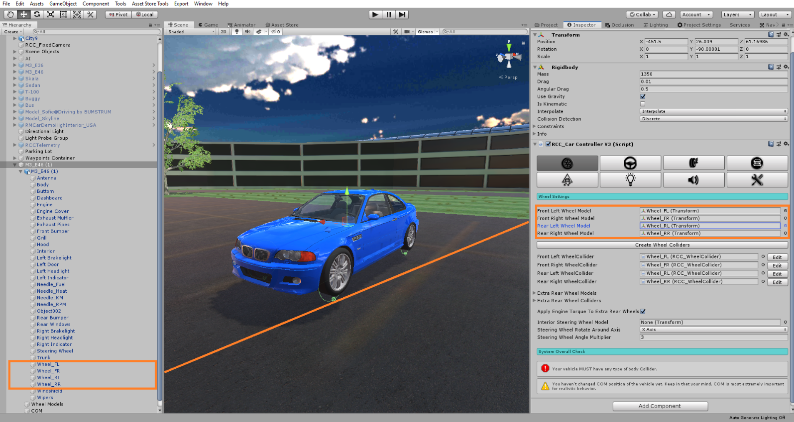
Generated Wheel Colliders settings are fine for 1250-1500 mass vehicles. If you have heavy vehicle such as bus or truck, you must increase Wheel Collider’s mass. This value is overrided by RCC_WheelCollider.cs right now.
Your vehicle MUST have one of any Colliders (Such as Box Collider, or Mesh Collider etc...) Otherwise, physics won’t work.

Spawning New Vehicles With Code
You don’t have to use GameObject.Instantiate() for spawning new vehicles. You can spawn new vehicles by just one line of code. You can take a look at API documentation.

Spawning New Vehicles With Given Position, Rotation, Sets It’s Controllable, And Engine State
You can spawn new vehicles by;
RCC.SpawnRCC(RCC_CarControllerV3 vehiclePrefab, Vector3 spawnPosition, Quaternion spawnRotation, bool registerAsPlayerVehicle, bool isControllable, bool isEngineRunning
);
As you can see, you can spawn your vehicle with given configuration by only one line of code.

Registering Vehicle As Player Vehicle
You can register the vehicle as player vehicle by;
RCC.RegisterPlayerVehicle(RCC_CarControllerV3 vehicle);

De-Registering Player Vehicle
You can de-register the player vehicle by;
RCC.DeRegisterPlayerVehicle ();

Setting Controllable State Of The Player Vehicle
You can set controllable state of the player vehicle by;
RCC.SetControl(RCC_CarControllerV3 vehicle, bool controlState)

Collider Shapes Of The Vehicle
This is one of the most important thing for physics behavior. Most devs are using mesh colliders for their vehicles. Remember that, shape of your vehicle collider will affect physics behavior directly. Let me explain this;
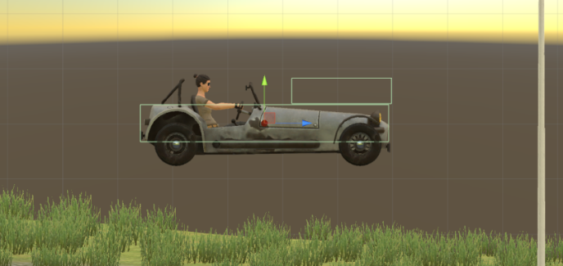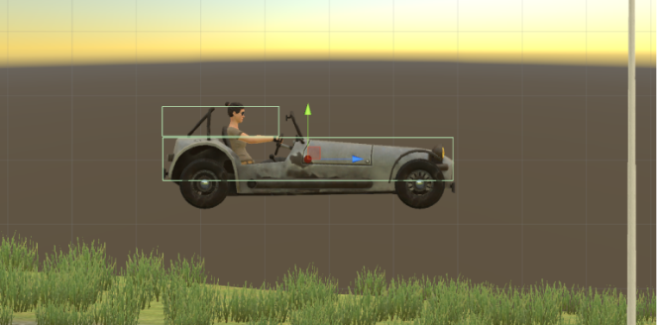
This vehicle has 2 Box Colliders. Second Box Collider is placed at front of the vehicle here on first screenshot. This will bring you more controllable and stable vehicle. Usually, second Box Collider should be at center Z of the vehicle for this model. But this is high speed vehicle, so it must be stable. That’s why I did this.

Second Box Collider is placed at rear of the vehicle on second screenshot. This will bring you more unstable and slippy vehicle. Differences between first colliders and second colliders are huge. Just remember that collider shapes are effecting vehicle behavior directly. If you want to make your cars stable, keep in that your mind.

After end up with wheel models and wheel colliders configurations, place your COM to correct place. This is our Center Of Mass. And COM’s position is effecting whole behavior. Usually COM of the vehicle is at just below about front seats. Engine and transmission is at front of the vehicle, and they are heavy. This model is RWD. It has shaft at middle and differential at back of the vehicle. So, I’ll just set it to just like this;

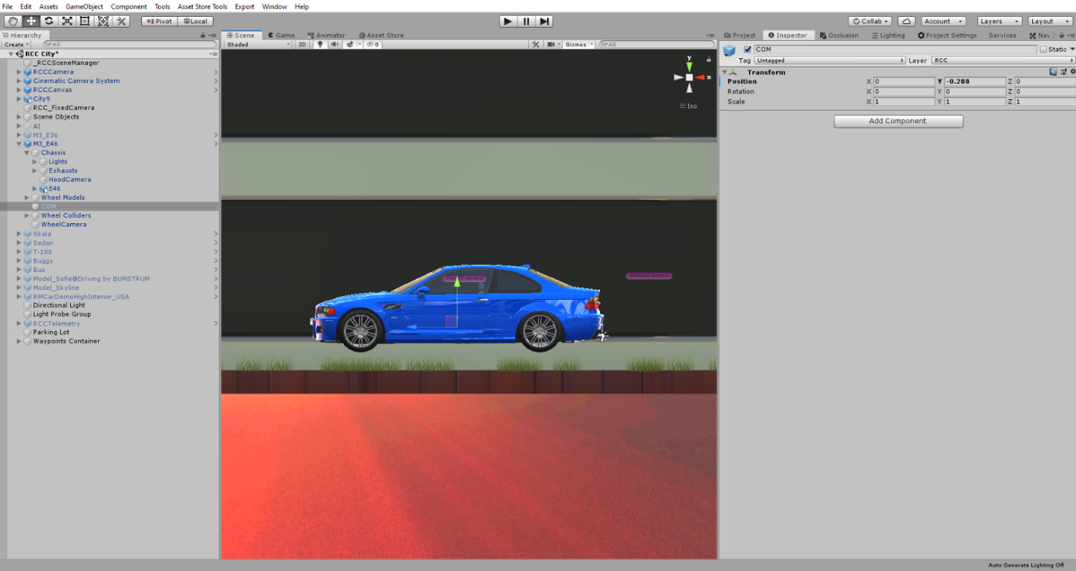
Runs perfectly after just few clicks.
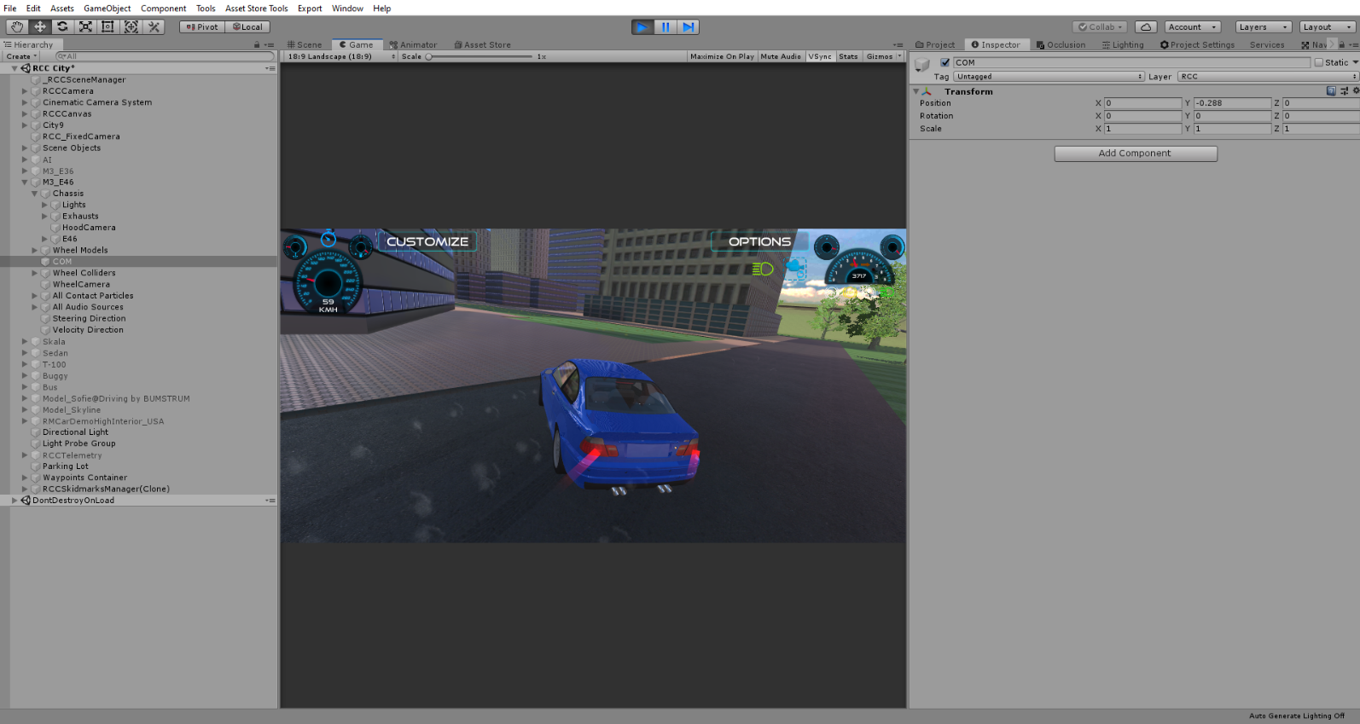
Configurate your vehicle as you wish. If you want to use manual gear, you need to set it from RCC Settings. Also you can select which key to shift up and shift down here.

Driving Assistances
Main Controller has ABS, TCS, ESP, Steering Assistance, and Traction Assistance. Threshold means, if wheel slip is equals or higher than this threshold value, corresponding assistance will be engaged immediately. Steering assistance will apply local Y axis torque to vehicle for more easily turns. But results more unrealistic turns like arcade games. 0.1f would be good for all vehicles. (0.2f will be used if behavior type is Racing or Semi-Arcade.)

Dashboard Configuration
You can access dashboard from RCC Settings.

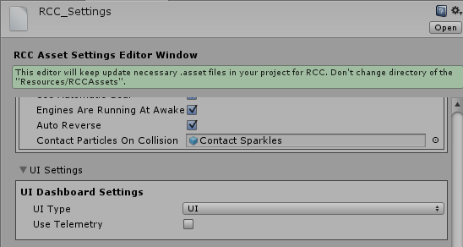
Default Dashboard Type is “UI”. Script will access “RCC_DashboardInputs.cs” and “RCC_DashboardDisplay.cs” scripts for displaying dashboard. These scripts are attached on RCCCanvas root.

Damage
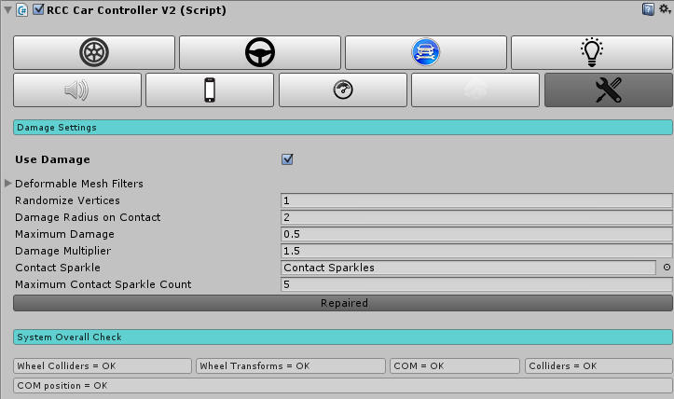

Your vehicle body mesh wireframe topology must be reliable for realistic vertices movement. If your vehicle body mesh has broken (unwelded) vertices or bad wireframe topology, mesh will deform buggy and unrealisticly. RCC takes all meshes of the vehicle if you haven’t select them specifically. If you want to select specific meshes, RCC won’t take all.

Creating Lights, Sounds, Skidmarks, Smoke Effects, And Other Features
These effects are optional. And can be created with In-Scene GUI buttons with fastest way. In order to enable buttons, simply go to Tools BCG RCC Enable In-Scene GUI Buttons.

Create point lights for braking and reverse gear, spot lights for headlights. Place them correctly on your vehicle model. You can create all kind of lights from Tools BoneCracker Games Realistic Car Controller Create Lights. Or with In-Scene GUI Buttons.
Script doesn’t Instantiate and destroys any smoke particles, or any kind of stuff. Just enabling/disabling particle emitters to avoid garbage memory.

You will find “RCCWheelSlipAsphalt”, “RCCWheelSlipGrass” and “RCCWheelSlipSand” prefabs under Prefabs folder. You can use your own smoke prefab as you wish. These wheel particles have been selected in Tools BCG RCC Edit Ground Materials.

If you want to use exhaust effects, you can create it from Tools BoneCracker Games Realistic Car Controller Create Misc. You need to place it to your model correctly. Or with In-Scene GUI Buttons.

Ground Materials
If you want to get variable tire grips on varied surfaces, you can use this feature. Open up Tools BoneCracker Games Realistic Car Controller Configure Ground Materials.
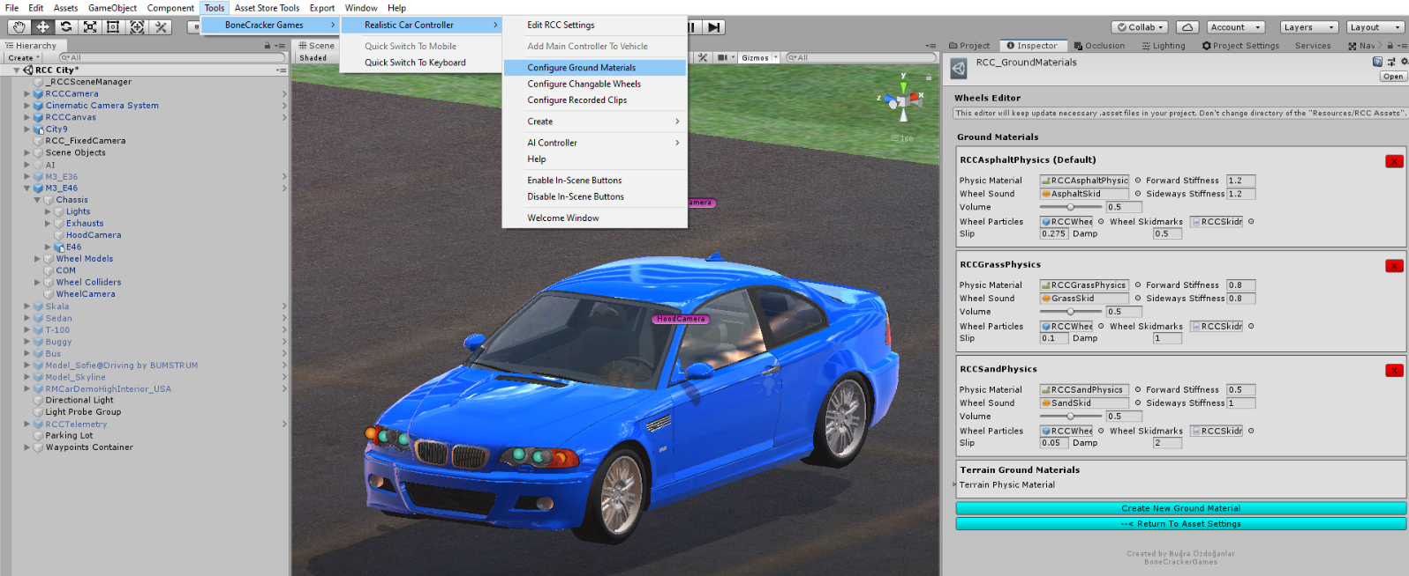
Currently 3 surfaces available such as Asphalt(Default), Sand, and Grass. You will find “RCCAsphaltPhysics”, “RCCGrassPhysics” and “RCCSandPhysics” Physic Materials in “Resources” folder. If your scene ground is not a Unity Terrain, and made by individual gameobjects, you have to assign each ground gameobject collider’s Physic Material to corresponding one. For ex. Select your grass ground gameobject, and select it’s collider’s Physic Material as “RCCGrassPhysics”.

Adjusting Ground Particles, Wheel Sounds, Damp, Forward and Sideway Stiffness, Slip On Different Grounds
You can adjust each materials Ground Particles, Wheel Sounds, Damp, Forward and Sideway Stiffness, Slip here.

As i said, these are optional effects. If you don’t want to use them, just leave.

Terrain Ground Materials
If your scene has a Unity Terrain as a ground, your terrain textures will decide which surface your on. Open up Tools BoneCracker Games Realistic Car Controller Configure Ground Materials. You will be able to configure existing ground materials, remove, or add new ones.

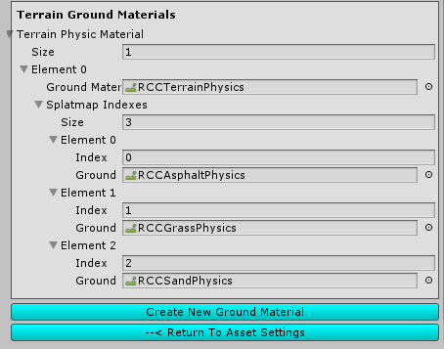

Select each index of your terrain texture slot for corresponding physics material. And yes, supports multiple terrains as well. Just be sure each terrain has unique physic material.

RCC Camera System

Main camera system desiged for using with RCC. Related with vehicle stats and includes 6 different camera modes with many customizable settings. It doesn't use different individual cameras on your scene. Simply it parents the camera to their positions that's all. No need to be Einstein.

If your scene doesn’t have RCC Camera, you can create it from Tools BoneCracker Games Realistic Car Controller Create Cameras Add RCC Camera To Scene.

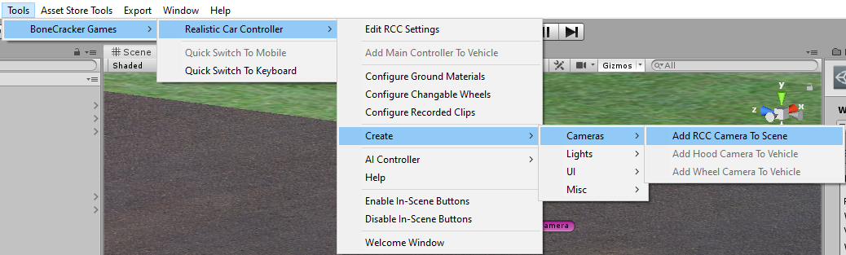

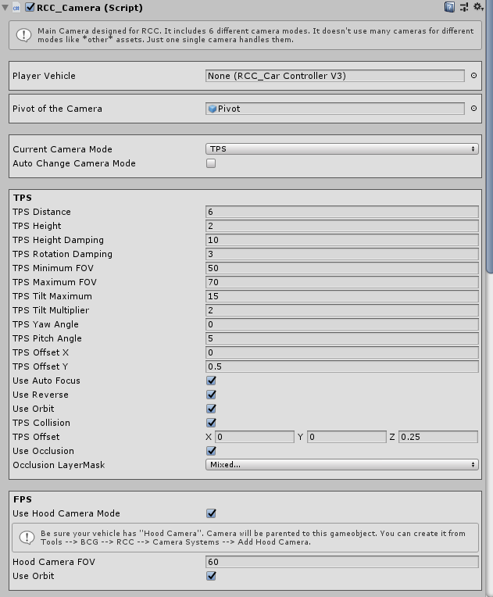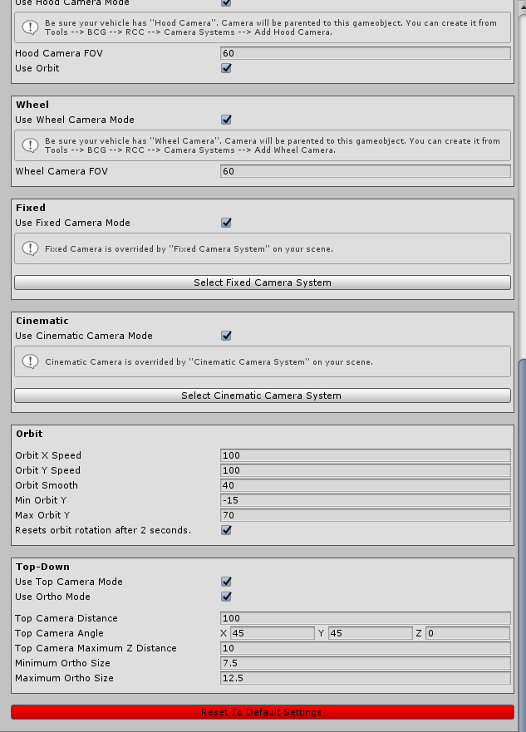

Record / Replay
Complete physics based record / replay system. player vehicle and all active AI vehicles can record / replay. All you have to do is press “R” for start recording, and “P” for start replay. These keys can be changed in RCC Settings. And of course, there is a UI button for mobile.

RCC_Recorder can be found at attached to _RCCSceneManager on your scene. Script will be added at awake, or you can add it by manually. You can use RCC’s API for start record / replay. For ex;

RCC. StartStopReplay ();
RCC. StartStopReplay (RCC_Recorder.Recorded recordedClip);
RCC. StartStopReplay (int index);
RCC. StartStopReplay (RCC_Recorder.Recorded recordedClip);

All records are stored in RCC_Records. You can access it from Tools BCG RCC Configure Recorded Clips.
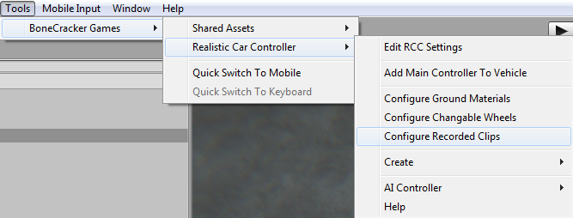
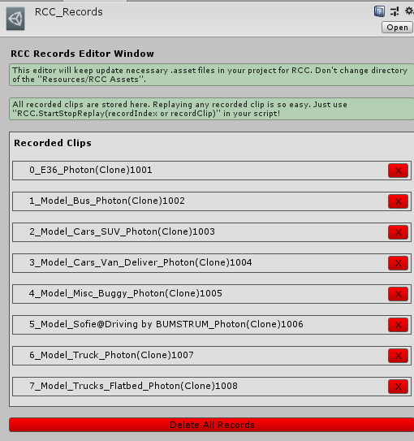

Customization
You can customize your vehicles by just calling a single method. Please take a look at “Realistic Car Controller V3 Scripts” documentation. All methods in RCC_Customization are explained there.

How The Customization Panel Works
I’ve wrote a example script called “RCC_CustomizerExample.cs”. Script is attached to RCCCanvas. UI Buttons in Customization Panel sends methods to this example script. And this example script uses static methods in RCC_Customization.cs for making changes. Let me explain it with simple examples;

We want to change front suspension distance of our car. So, we have to call it;
RCC_Customization.SetFrontSuspensionsDistances (targetRCC,.targetValue);

We want to repair our car. So, we have to call it;
RCC_Customization. RepairCar (targetRCC);
We want to change drivetrain of our car to AWD. So, we have to call it;
RCC_Customization. SetDrivetrainMode (targetRCC,. RCC_CarControllerV3.WheelType.AWD
);
And goes on... Simply take a look at all methods in RCC_CustomizerExample.cs script, you will see how did I modify the player vehicle by using RCC_Customization.cs script.
RCC_CustomizerExample.cs attached to RCC Canvas.
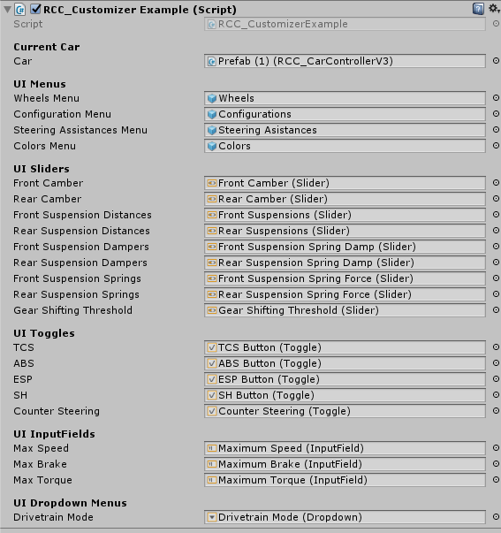
This example script handles all UI menus, buttons, sliders, toggles, inputfields, and dropdown menus. It just receives inputs from UI, and fires necessary actions.

AI Configuration

Creating NavMesh For Scene
AI is based on Unity’s Nav Mesh. Therefore, you must bake and create navigation mesh for your scene. Select your all static objects (including road too). And set them as “Static”. 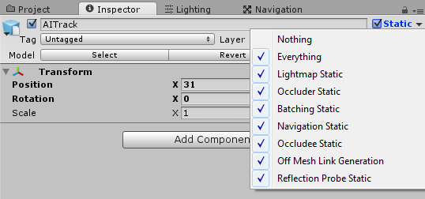

When all your static objects are marked as “Static”, then you can bake your navigation mesh. Open “Navigation” window from Window Navigation.
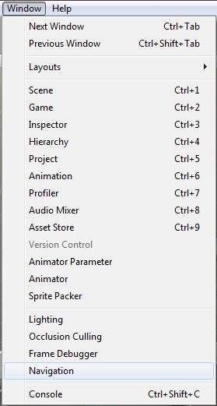
Default settings should be like this;
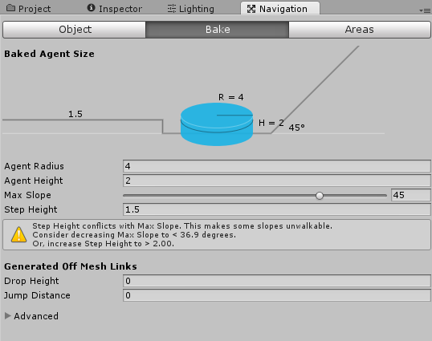

And then, click the bake button and bake your scene. Check your blue navigation mesh. Should be like this;
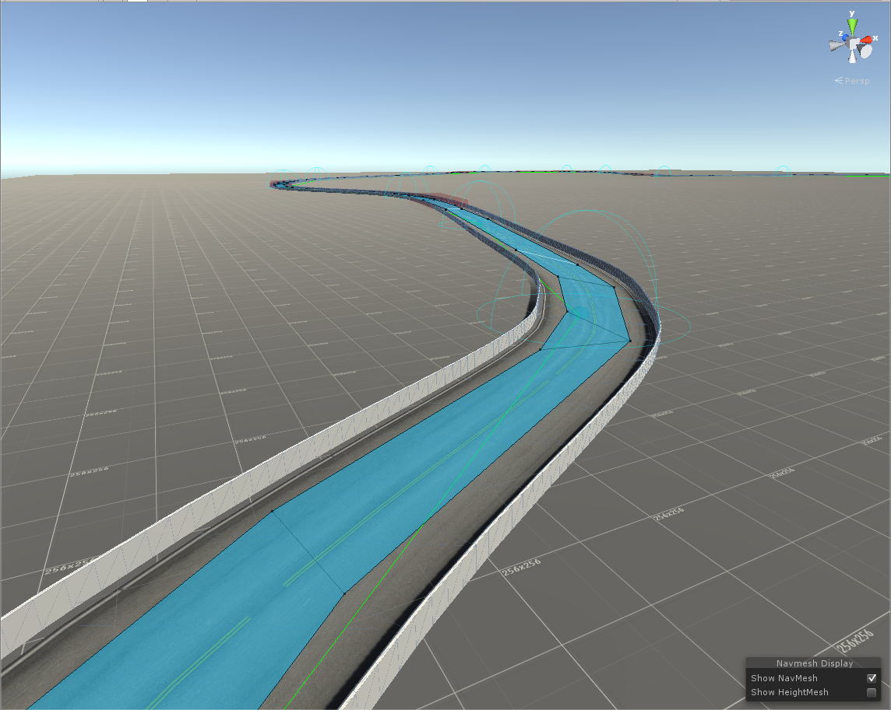

Adding AI Controller To Vehicle
First, build and configurate your vehicle. When everything works fine and results are as expected, you can add AI Controller to your vehicle by clicking “Tools BoneCracker Games RCC AI Controller Add AI Controller To Vehicle”
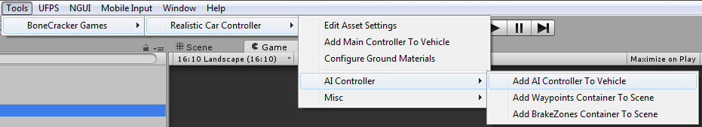

This will add “RCC_AIController” to root of your vehicle.
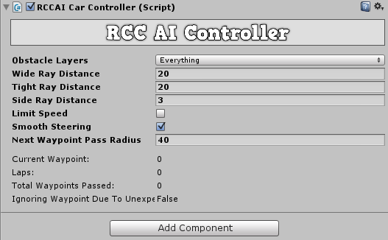

Vehicle will use “Nav Mesh Agent” for road path based on your waypoints, and will use raycasts for dynamic objects. If you have specified gameobjects for ignoring raycasts for this gameobject, you can select your gameobject layer from obstale layers.

Adding Waypoints Container To Scene
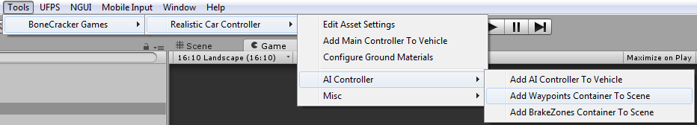

This will add “RCC AI Waypoints Container” to your scene. Simply hold Shift and left click on your road to create a new waypoint. Create your path with them.
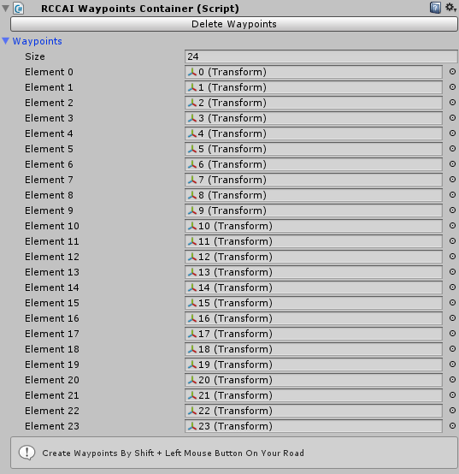
Warning: Do not use CTRL+D for duplicate any waypoint.

Adding BrakeZones Container To Scene
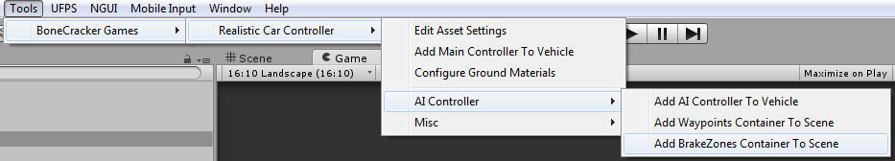

This will add “RCC AI BrakeZones Container” to your scene. Simply hold Shift and left click on your road to create a new brake zone.
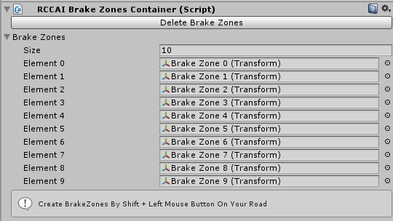
Info: Do not use CTRL+D for duplicate any brake zone.

Each brake zone has a target speed. Vehicle will adapt its speed to this target speed when in this brakezone. You can scale your brakezones to fit to your road section.

Enter-Exit System
First, you have to import “BCG Shared Assets” into your project. It will add necessary scripts and resources to use your FPS or TPS player for enter-exit vehicles. Package is located in “For BCG Shared Assets” folder. There will be two new scenes in your “Demo Scenes” folder. All you have to do is, add necessary scripts to vehicle and player. Get out positions are created automatically in script if you don’t select it in RCC_EnterExitCar.
For FPS characters, it will depend on your camera of the FPS player. For TPS player, it depends on your actual TPS Player, not camera.

Multiplayer with Photon2
You have to import the necessary scripts to the project. First, download and import Photon2. Pass your AppID to Photon setup (expalined below), and then import “RCC_PhotonNecessaryScripts” in Scripts/Photon folder. Now you can test the Photon demo scene.

There should be a new scene named “RCC City Photon2” in Demo Scenes folder. Same scene with regular city scene. Only difference is, this scene has Photon Network Manager.

Well, it’s quite easy I guess. If you don’t know anything about Photon, or even multiplayer based game, here is the events for how it works;

1 – First, you have to connect to server. In this case, our server is Photon Cloud Server.
2 – If your connection to server succeeded, you will be in lobby. Now you can create your room, or join someones room, or join randomly room here.
3 – Congrats, now you are in an online multiplayer based room in realtime.

As soon as you have imported it to your project, it will ask your AppID. Pass it. And now you are ready to develop your realtime based multiplayer levels. It’s free. And of course you are limited with 20 CCU.

Photon2 has many simple methods in their API. It’s extremely easy to understand. Let me explain how the demo scene works;
Demo scene has a gameobject with script named “RCC_PhotonManager”. This script handles multiplayer section of the scene. Uses these methods (You can find all methods from Photon2’s docs);

Photon.Pun.PhotonNetwork.ConnectUsingSettings ();
We are connecting to the server first. We can listen which connection status we are on in OnGUI() method. Like this;
GUILayout.Label("State: " + Photon.Pun.PhotonNetwork.NetworkClientState.ToString());
Once connection to the server established, we have to join lobby.
Photon.Pun.PhotonNetwork.JoinLobby ();
As soon as we are connected to lobby, we want to join a random room by;
Photon.Pun.PhotonNetwork.JoinRandomRoom();
If it fails, this means there are no any active other room. We are creating the new room by Photon.Pun.PhotonNetwork.CreateRoom(null); This method needs room name. I didn’t use it, because there are no any room list in demo.

I take a string that belongs to player here. And set it by Photon.Pun.PhotonNetwork.NickName = name; Enabling/disabling few UI gameobjects depends on connection state. That’s basically, how the demo scene works.

For vehicle sync, each vehicle has PhotonView.cs and RCC_PhotonNetwork.cs. These scripts are necessary for each vehicle. RCC_PhotonNetwork.cs is observed by PhotonView.cs.

RCC_PhotonNetwork.cs is synchronizing all control inputs, transform position, rotation, and rigid velocity smoothly. If vehicle is our vehicle, it will broadcast your data to the server. If vehicle is not our vehicle, it will receive all data from server.

These vehicles are not instantiated or destroyed with regular GameObject.Instantiate or Destroy. You have to do it with PhotonNetwork.Instantiate or Destroy. Unfortunately, it won’t work with your prefab. It accepts only strings for your vehicle. That means, it will use Resources folder for accessing your vehicles. Your vehicle prefabs must be at Resources folder. Therefore, there are two canvases in resources folder. One of them is using RCC_Demo.cs, other one is using RCC_PhotonDemo.cs.

Credits

Sofie With Animations by 3DMaesen
Driver Sofie, her animations, and her car model made by 3DMaesen. You can access 3DMaesen asset store from this link;
http://u3d.as/2vg

Sound Effects
All sounds in package are completely Royalt Free. You can use them on any personal or commercial projects. You can’t redistribute / resell them.

License
You can use this package for unlimited games. Both personal and commercial use. But you can’t resell or redistribute any asset in the package on any store (not even any single asset in package). I got many reports from my customers about some fake developers are reselling my package on other stores. This is strictly forbidden. You can’t resell or redistribute ANY asset from Unity’s Asset Store, unless if developer gave you special license for making this. If anyone violates this, he will be banned, and his revenue from package sellings will be interrupted. You can read Unity EULA from this link;
http://unity3d.com/legal/as_terms

So, how you holding up there? You can ask me anything about my assets! If you want change minor things in the package, don’t waste your time by editing scripts. Just tell me, I’ll do my best with no cost. I don’t take any projects right now, and I’m not available for hire. Please mail me if you used any of my assets in your game. I’d like to see it in action!

Made by Buğra Özdoğanlar
Bonecrackergames@gmail.com

